RESUME

DHAREDDY ROHITH REDDY
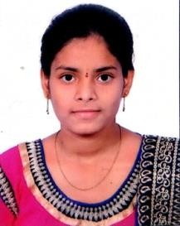
Email id: rohithreddy5048@gmail.com
Mobile: 6300493135

Objective:

- To enhance my professional skills, capabilities and knowledge in an organization which recognizes the value of hard work and trusts me with responsibilities and challenges.

Education:

Course | Institution | Year of passing | Percentage/cgpa
B. Tech(CSO)  ( pursing) | Ace engineering  college | 2025 | 8.3 gpa
Board of intermediate | Narayana junior  college | 2021 | 92%
Secondary School  (SSC) | Narayana High  School | 2019 | 9.5 gpa
Skills:

- Personal skills : Adaptability, Hard Working.
- Programming skills : Java, C, Python.
- Operating Systems : Windows, linux.
- Database : Mysql.

Projects:
- Developed projects on arduinaUi and raspberry pi

Certifications:

- I have completed a Salesforce certification and got certified

Extra-circular &Co-circular Activities:

- Participated in Robotics workshop organised by Soham
Personal Details:

Name : Dhareddy Rohith Reddy

D.O.B : 27/04/2004

Father’name : D Krishna Reddy Gender : Male Language known : English, Telugu
Address : 1-75/5/2 ,Srinivas Nagar Boduppal

Medchal dist ,pincode:500092

Declaration:

- I hereby declare that the information mentioned above are correct to best of my knowledge and belief

D. Rohith Reddy

